Private wells in Westminster contaminated with carcinogens
Emilia Cardona Gardner News

WESTMINSTER — Wells at more than 218 properties along Bean Porridge Hill Road and the Crocker Pond area have had PFAS levels that are 50 times what state regulations consider safe to drink.
The per- and polyfluoroalkyl substances or PFAS, called forever chemicals because they can stay in the environment permanently, leaked from organic waste located at the Massachusetts Natural Fertilizer facility at 65 Bean Porridge Hill Road. MNF and the property owners Otter Farms Inc. have begun a cleanup plan in the past nine months to reverse the damage.
Massachusetts Department of Environmental Protection was notified in February when a MassDEP certified private commercial water testing lab did a routine test for a Bean Porridge Hill Road resident. Then MassDEP informed MNF and Otter Farms about the contamination. For timely updates on water quality test results and other resources about the PFAS contamination visit westminsterpfas.com.

MassDEP is the driving force for remediation
"We have leaned really heavily on MassDEP and other towns who have encountered these issues for guidance and advice. We are working hand in hand with MassDEP this entire time," Town Administrator Stephanie Lahtinen said. "It was pretty clear from the beginning that MassDEP was the driving force here because they are the ones who deal with groundwater contamination, the environmental impacts and, assigning who the responsible parties are and what the remediation efforts should be."
MNF and Otter Farms hired an environmental consultant to guide them through an immediate response action plan in March 2022. Otter Farms hired Tighe & Bond while MNF hired, Lessard Environmental, Inc. The environmental consultants have provided
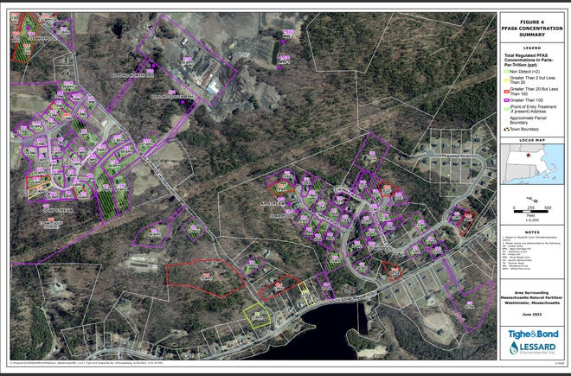
the affected residents with a bottled water service and are installing point of entry, or POET, systems to filter the PFAS out of the water at every private well contaminated. Since late April, the consultants have installed about 161 filtration systems. Dozens more homes on White Pine Drive, South Ashburnham Road, and other neighboring streets are waiting for quality water test results that will determine if the contaminants have spread into their water supply.
The president of Lessard Environmental Inc., Larry Lessard, said the bottled water service, the water testing, and the POET installations are all paid by MNF and Otter Farms. He said the lifespan of the filters may vary on how high the PFAS levels are and how much water each home uses on the daily.
"The first six (POET systems) installed, were at locations with the highest concentrations and none of those should lead to the change of the activated carbon filter yet," Lessard said. "There are sediment filters and things like that that get changed on some frequency. You know we've got the plumbing contractor working with us do that work."
More installations will be done in the coming months because more water tests have come back positive for high levels of contamination.

What are PFAS?
PFAS is a family of six man-made chemical compounds that take thousands of years to break down and are used in daily household items. Since the 1950s, pre- and polyfluoroalkyl substances have been used to manufacture highly durable stain-resistant, water resistant, and non-stick products.
PFAS are nearly impossible to avoid because most items used daily contain the substance everything from household cleaning products to microwavable popcorn to raincoats.
There are little to no state or federal regulations that protect private well water from contamination of any kind. MassDEP does have guidelines and recommendations on what private well owners can do to protect their water supply. To learn more, visit the MassDEP website Protect Your Family: A Guide to Water Quality Testing for Private Wells | Mass.gov.

What private well owners should know
Owners have the responsibility of protecting their own well water supply.
Contamination of private well water happens more often than the public realizes, said Amie Shei, president and CEO of The Health Foundation of Central Massachusetts that focuses on improving the health of residents in central Massachusetts.
In partnership with non-profit organization, Resources for Communities and People Solutions, the foundation is funding the Private Well Program to Protect Public Health | RCAP Solutions to provide financial assistance to homeowners and create public awareness on the lack of private well water regulations.
"The cost for a private well water test can range from probably $100 to $500, depending on which contaminants you're testing for, and I think those PFAS tests have become more expensive recently because the demand for those tests has increased," Shei said. "There's no ongoing program that provides free testing."
The more expensive part is cleanup.
"When a contaminant is found and some sort of treatment system needs to be installed, that can cost from $1,000 to $5,000, sometimes even more," Shei said "That can be a major expense for a homeowner especially a low-income homeowner or perhaps a senior citizen with a fixed income so that again is why we're trying to identify some financial assistance programs for private well owners."
Shei said regular maintenance, inspection and testing are the keys to keeping your family safe when using a private well water supply. When buying a new home, prospective buyers should test the water if the house is served by a private well, Shei said.

